Berkshire Asset Management
46 Public Square, Suite 700
Wilkes-Barre, PA 18701
570.825.2600

“Casual Friday” Commentary

Casual Friday: Feels Like 2008... Sorta? + Social Setting Playbook – September 30th, 2022
#TGICF!
We have many advisor friends affected by IAN. STAY SAFE!
Marketwise...
Just in time for October, it feels like 2008 all over again - sorta.
Bonds are not our specialty, but here are a few quick observations…
The spectacular bear of 2008 created epic headlines; equities declined -37% for the calendar year. What got little attention? Bonds were UP 5% that year. So if you had a balanced account comprised of index funds, you returns looked something like this:
2008 | Return | Allocation | Contribution to Return
S&P 500 | -37.00% | 60.00% | -22.20%
Barclays Int Gov Credit | +5.08% | 40.00% | +2.03%
 |  | Blended Return | -20.17%
Returns represent 2008 full calendar year.
Perhaps this year’s equity decline feels a bit more gradual and dare we say “quieter” than 2008’s “spectacular-headline-grabbing-horror show”, net-net the damage is nearly the same.
2022 YTD (09.28.2022) | Return | Allocation | Contribution to Return
S&P 500 | -22.72% | 60.00% | -13.63%
Barclays Int Gov Credit | -9.54% | 40.00% | -3.82%
 |  | Blended Return | -17.45%
Returns represent partial year as of 9.28.2022

We are pleased to report your (hopefully) favorite dividend manager is holding in relatively well, down roughly 45% less than some major indices.
Berkshire Dividend -14.23% Net of Fees (YTD as of 9.29.2022)
So what’s next?
Bond/inflation/rate wise, something might be about to give...
Mortgage rates are now over 6.50% the highest they’ve been in 14 years.
Housing prices are under pressure.
Key industrial commodities HAVE rolled over...
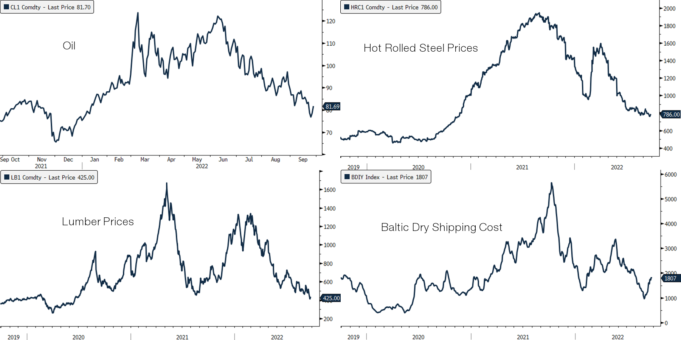

What to do?
Growth stocks, the relative “haven” of the pandemic now:
- Seem to be behaving worse on days the market is down
- Continue to look very expensive to value
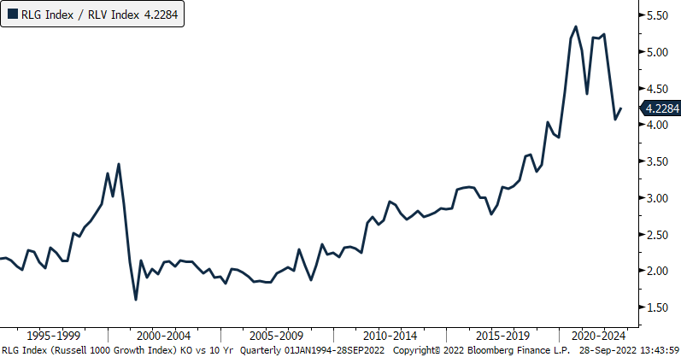
Many media folks and strategists are sounding panicky, insisting that rates/inflation will keep spiraling ever higher. We are not bond managers or interest rate prognosticators… but many of today's forces feel deflationary, not inflationary.
Longer bonds and defensive equities anyone?
Social Setting Playbook:
Ever wonder how to effectively mix business with pleasure without becoming "that guy" everyone wants to avoid because they are worried about getting "hit up?" This week, Berkshire's own Jason Reilly, VP CFP presents dignified ways to tastefully engage prospects in social settings.

Having trouble viewing? View on LinkedIn
Casual Friday Bonus:
It's always inspiring when a sports milestone is conquered…
and it's cool to look back at a couple old videos #vintage
https://www.mlb.com/news/roger-maris-stats-and-facts
Have a great weekend,
Gerry
Gerard Mihalick, CFA
Dividend Strategy Portfolio Manager/Partner
Berkshire Asset Management, LLC
Office (570) 825 – 2600

Berkshire Dividend Growth SMA is available through various custodians, broker-dealers and UMA providers. This commentary is Intended for Institutional and advisor use only. This commentary may make information of third parties available via website links. The Third-Party Content is not created or endorsed by Berkshire nor any business offering products or services through it. The delivery of Third-Party Content is for general informational purposes only and does not constitute a recommendation or solicitation to purchase or sell any security or make any other type of investment or investment decision. In addition, the Third-Party Content is not intended to provide tax, legal or investment advice. the Third-Party Content provided to is obtained from sources believed to be reliable and that no guarantees are made by Berkshire or the providers of the Third-Party Content as to its accuracy, completeness, timeliness.

Berkshire Asset Management, LLC claims compliance with the Global Investment Performance Standards (GIPS®). Berkshire Asset Management is a fee-based, SEC registered advisory firm serving the portfolio management needs of institutional and high-net worth clients. The Dividend Growth Composite contains portfolios invested in Berkshire’s Dividend Growth Strategy with an equity allocation target of 90% - 100%. The Dividend Growth Strategy’s primary objective is to generate a growing stream of equity income by investing in a diversified portfolio of equities with stable, high, and growing dividends. The benchmark is the S&P 500 Index. The index returns are provided to represent the investment environment existing during the time periods shown. For comparison purposes, the index is fully invested, does not include any trading costs, management fees, or other costs, and the reinvestment of dividends and other distributions is assumed. An investor cannot invest directly in an index. Gross returns are presented before management and other fees but after all trading expenses. Net returns are calculated by deducting actual management fees from gross returns. Returns reflect the reinvestment of dividends and other earnings. Valuations are computed and performance is reported in U.S. dollars. To receive a complete list of composite descriptions and/or a compliant presentation, contact Jason Reilly, CFP® Tel: 570-825-2600 or info@berkshiream.com. Past performance does not guarantee future results.

Definitions: The S & P 500 Index is a market capitalization weighted index of the largest 500 U.S. stocks. It is a market-value weighted index (stock price times # of shares outstanding), with each stock’s weight in the index proportionate to its market value. The index is designed to measure changes in the economy and is representative of most major industries. Russell 1000 Growth Index measures the performance of those Russell 1000 companies with higher price-to-book ratios and higher forecasted growth values. The index was developed with a base value of 200 as of August 31, 1992. Russell 1000 Value Index measures the performance of those Russell 1000 companies with lower price-to-book ratios and lower forecasted growth values. The index was developed with a base value of 200 as of August 31, 1992. You cannot invest directly in an index. BEst (Bloomberg Estimates) Earnings Per Share (EPS Adjusted) estimate returns Earnings Per Share from Continuing Operations, which may exclude the effects of one-time and extraordinary gains/losses. Beta is a measure of volatility vs. an index. Upside/Downside capture ratios refer to a portfolios performance as a percentage of either positive returns (upside) or negative returns (downside) vs. an index. Standard Deviation is a measure of total risk. Alpha, Beta and capture ratios are represented as calculated by Morningstar.

Risks: Past performance does not guarantee future results. Different types of investments involve varying degrees of risk, and there can be no assurance that any specific investment will either be suitable or profitable for an individual’s investment portfolio. Dividends are subject to change, are not guaranteed, and may be cut. Investing based on dividends alone may not be favorable as it does not include all material risks. There is no guarantee any stated (or implied) portfolio or performance objective mentioned by Berkshire can be met. Berkshire’s equity style may focus its investments in certain sectors or industries, thereby increasing potential volatility relative to other strategies or indices. The dividend strategy may include bundled services also known as a “wrap fee program”. Because there is typically a low turnover in the strategy, this may be more costly for some investors. No one should assume that any information presented serves as the receipt of, or a substitute for, personalized individual advice from a qualified advisor or any other investment professional.

Market Commentary, Aggregate Holdings, Securities, Sectors, Portfolio Characteristics Mentioned: No statement made in this presentation shall construe investment advice. This presentation is for informational purposes only. Views, comments or research mentioned is not intended to be a forecast of future events. The mention of any security or sector is not deemed as a recommendation to buy or sell. Any reference to any security or sector is used to explain the portfolio manager’s rationale for portfolio decisions or philosophy. Research or financial statistics cited regarding securities or sectors do not contain all material information about them. Any securities mentioned represent a partial list of holdings whereas Berkshire portfolios typically contain approximately 30-40 securities in percentage weightings ranging from 1-5%. A complete list of holdings from a representative account is available upon request. Overall portfolio characteristics mentioned are from a representative account deemed representative of the strategy; data may be compiled from Bloomberg, Baseline or Berkshire estimates. Individual holdings, performance and aggregate characteristics of actual portfolios may vary based on a variety of factors including market conditions, timing of client cash flows and manager discretion. This presentation contains Berkshire opinions and use of Berkshire estimates which are subject to change at any time. Berkshire employees may have personal positions in any securities or sectors mentioned. Charts, presentations or articles may be obtained from third parties and Berkshire does not guarantee their accuracy. *Platform restrictions may apply. Preliminary returns are based on composite estimates only. Individual accounts will vary. Copyright © 2021 Berkshire Asset Management, LLC, All rights reserved.

